

NAME | REG NO | COURSE
NAKANWAGI CATHERINE | BU/UG/2025/4412 | AMI
AYEBALE LAMEX | BU/UG/2025/4410 | AMI
ATUHAIRWE DEOGRATIUS | BU/UG/2025/4409 | AMI
WEMBABAZI IVAN | BU/UG/2025/4414 | AMI
NSAMBA GODWIN | BU/UP/2025/1960 | AMI
WAMUWAYA SULAIMAN | BU/UP/2025/2146 | AMI

Numerical Methods using FOR and WHILE Loops
Newton-Raphson, Secant and Runge-Kutta: flowcharts, pseudo code and MATLAB code
Each method is solved on one standard problem and written twice, once with a for loop and once with a while loop. For every version you will find the flowchart, the pseudo code, the MATLAB code and the expected output.

1. Newton-Raphson Method
Find the real root of f(x) = x³ − 2x − 5 with initial guess x0 = 2, tolerance 10⁻⁶.
Formula: x(n+1) = x(n) − f(x(n)) / f′(x(n)), where f′(x) = 3x² − 2

A. Solution using a FOR loop

Flowchart
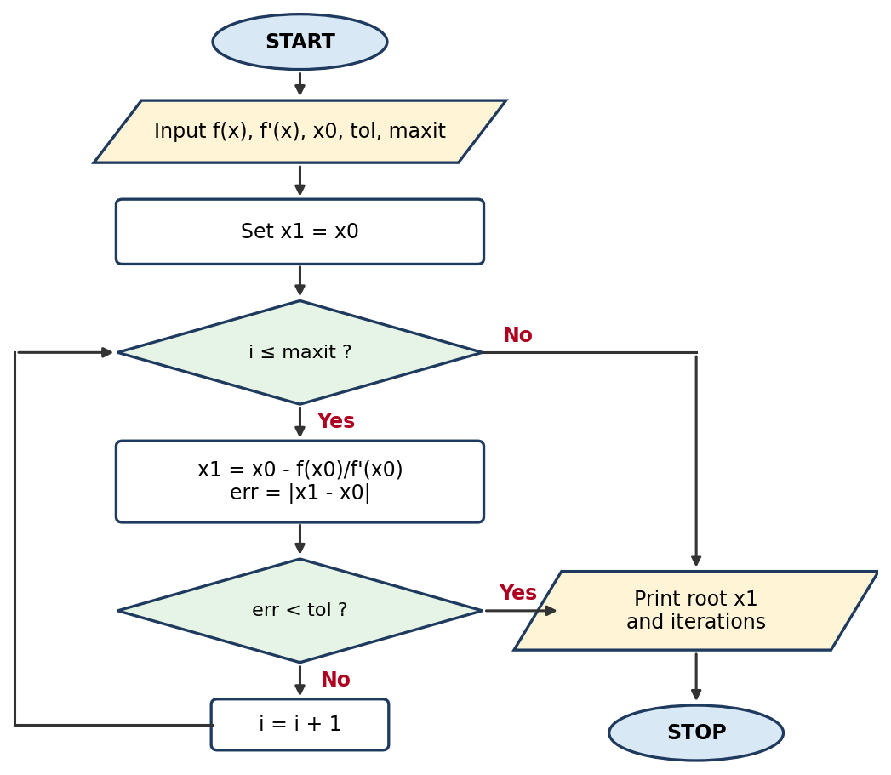

Pseudo code
START
INPUT f(x), f'(x), x0, tol, maxit
FOR i = 1 TO maxit
x1 = x0 - f(x0) / f'(x0)
err = |x1 - x0|
PRINT i, x1, err
IF err < tol THEN
BREAK
ENDIF
x0 = x1
ENDFOR
PRINT root x1 and number of iterations
STOP

MATLAB code
% Newton-Raphson method using a FOR loop
clc; clear;

f = @(x) x^3 - 2*x - 5;
df = @(x) 3*x^2 - 2;
x0 = 2; tol = 1e-6; maxit = 50;

for i = 1:maxit
x1 = x0 - f(x0)/df(x0);
err = abs(x1 - x0);
fprintf('Iter %2d: x = %.8f error = %.2e\n', i, x1, err);
if err < tol
break
end
x0 = x1;
end
fprintf('Root = %.6f found in %d iterations\n', x1, i);

Output (same for both versions)
Iter 1: x = 2.10000000 error = 1.00e-01
Iter 2: x = 2.09456812 error = 5.43e-03
Iter 3: x = 2.09455148 error = 1.66e-05
Iter 4: x = 2.09455148 error = 1.56e-10
Root = 2.094551 found in 4 iterations

B. Solution using a WHILE loop

Flowchart
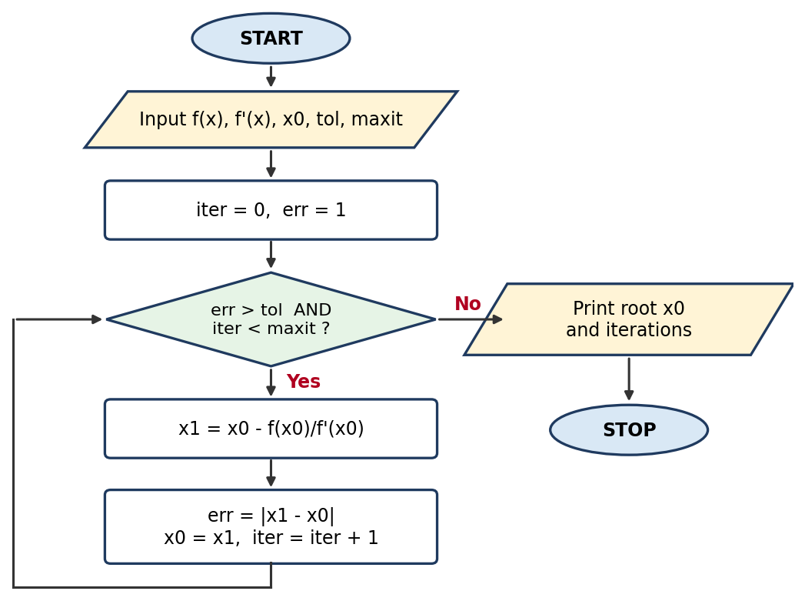

Pseudo code
START
INPUT f(x), f'(x), x0, tol, maxit
iter = 0
err = 1
WHILE err > tol AND iter < maxit
x1 = x0 - f(x0) / f'(x0)
err = |x1 - x0|
x0 = x1
iter = iter + 1
PRINT iter, x0, err
ENDWHILE
PRINT root x0 and number of iterations
STOP

MATLAB code
% Newton-Raphson method using a WHILE loop
clc; clear;

f = @(x) x^3 - 2*x - 5;
df = @(x) 3*x^2 - 2;
x0 = 2; tol = 1e-6; maxit = 50;
iter = 0; err = 1;

while err > tol && iter < maxit
x1 = x0 - f(x0)/df(x0);
err = abs(x1 - x0);
x0 = x1;
iter = iter + 1;
fprintf('Iter %2d: x = %.8f error = %.2e\n', iter, x0, err);
end
fprintf('Root = %.6f found in %d iterations\n', x0, iter);

Output (same for both versions)
Iter 1: x = 2.10000000 error = 1.00e-01
Iter 2: x = 2.09456812 error = 5.43e-03
Iter 3: x = 2.09455148 error = 1.66e-05
Iter 4: x = 2.09455148 error = 1.56e-10
Root = 2.094551 found in 4 iterations

2. Secant Method
Find the real root of f(x) = cos(x) − x with initial guesses x0 = 0 and x1 = 1, tolerance 10⁻⁶.
Formula: x(n+1) = x(n) − f(x(n)) · (x(n) − x(n−1)) / (f(x(n)) − f(x(n−1)))

A. Solution using a FOR loop

Flowchart
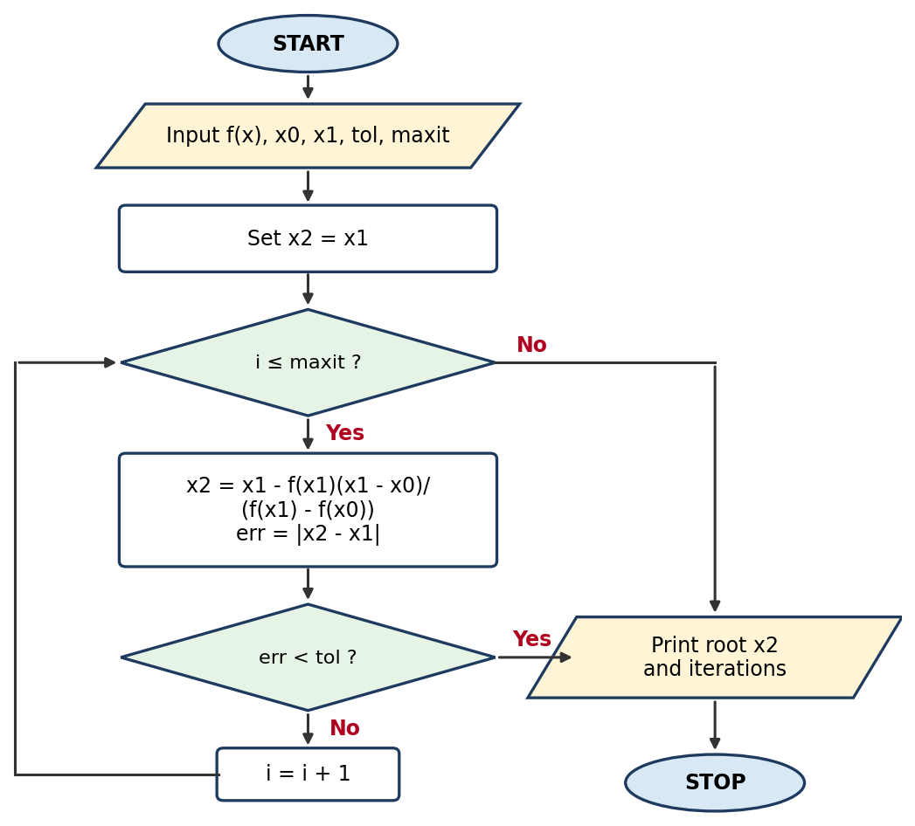

Pseudo code
START
INPUT f(x), x0, x1, tol, maxit
FOR i = 1 TO maxit
x2 = x1 - f(x1)*(x1 - x0) / (f(x1) - f(x0))
err = |x2 - x1|
PRINT i, x2, err
IF err < tol THEN
BREAK
ENDIF
x0 = x1
x1 = x2
ENDFOR
PRINT root x2 and number of iterations
STOP

MATLAB code
% Secant method using a FOR loop
clc; clear;

f = @(x) cos(x) - x;
x0 = 0; x1 = 1; tol = 1e-6; maxit = 50;

for i = 1:maxit
x2 = x1 - f(x1)*(x1 - x0)/(f(x1) - f(x0));
err = abs(x2 - x1);
fprintf('Iter %2d: x = %.8f error = %.2e\n', i, x2, err);
if err < tol
break
end
x0 = x1;
x1 = x2;
end
fprintf('Root = %.6f found in %d iterations\n', x2, i);

Output (same for both versions)
Iter 1: x = 0.68507336 error = 3.15e-01
Iter 2: x = 0.73629900 error = 5.12e-02
Iter 3: x = 0.73911936 error = 2.82e-03
Iter 4: x = 0.73908511 error = 3.42e-05
Iter 5: x = 0.73908513 error = 2.11e-08
Root = 0.739085 found in 5 iterations

B. Solution using a WHILE loop

Flowchart
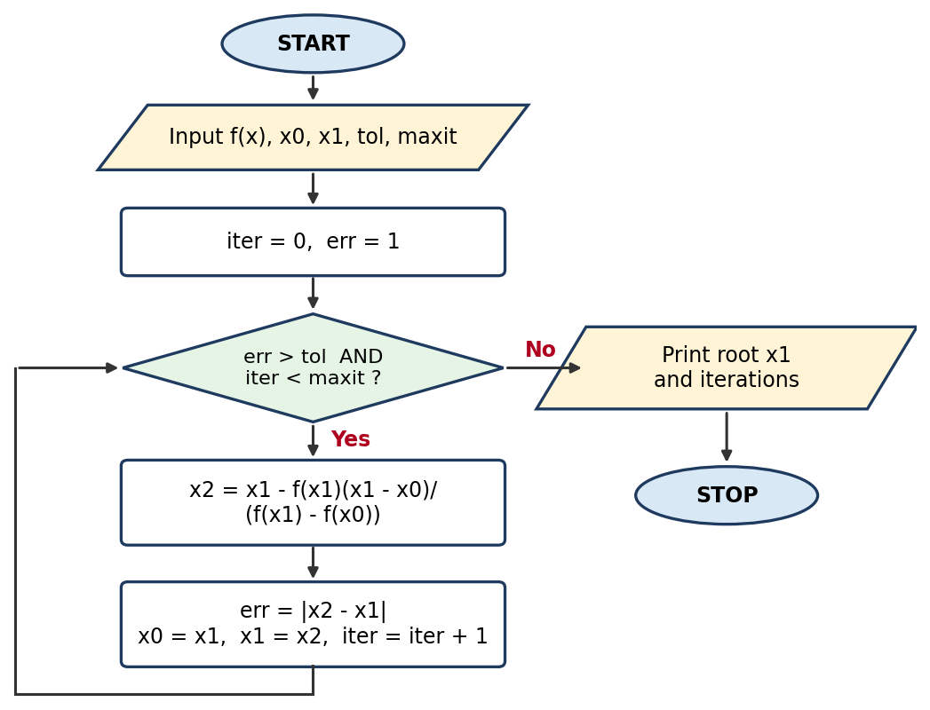

Pseudo code
START
INPUT f(x), x0, x1, tol, maxit
iter = 0
err = 1
WHILE err > tol AND iter < maxit
x2 = x1 - f(x1)*(x1 - x0) / (f(x1) - f(x0))
err = |x2 - x1|
x0 = x1
x1 = x2
iter = iter + 1
PRINT iter, x1, err
ENDWHILE
PRINT root x1 and number of iterations
STOP

MATLAB code
% Secant method using a WHILE loop
clc; clear;

f = @(x) cos(x) - x;
x0 = 0; x1 = 1; tol = 1e-6; maxit = 50;
iter = 0; err = 1;

while err > tol && iter < maxit
x2 = x1 - f(x1)*(x1 - x0)/(f(x1) - f(x0));
err = abs(x2 - x1);
x0 = x1;
x1 = x2;
iter = iter + 1;
fprintf('Iter %2d: x = %.8f error = %.2e\n', iter, x1, err);
end
fprintf('Root = %.6f found in %d iterations\n', x1, iter);

Output (same for both versions)
Iter 1: x = 0.68507336 error = 3.15e-01
Iter 2: x = 0.73629900 error = 5.12e-02
Iter 3: x = 0.73911936 error = 2.82e-03
Iter 4: x = 0.73908511 error = 3.42e-05
Iter 5: x = 0.73908513 error = 2.11e-08
Root = 0.739085 found in 5 iterations

3. Runge-Kutta Method (4th Order)
Solve dy/dx = x + y with y(0) = 1 over 0 ≤ x ≤ 1 using step size h = 0.1. The exact solution y = 2eˣ − x − 1 is used for comparison.
Formula: y(n+1) = y(n) + (h/6)(k1 + 2k2 + 2k3 + k4), with k1 = f(x,y), k2 = f(x+h/2, y+h·k1/2), k3 = f(x+h/2, y+h·k2/2), k4 = f(x+h, y+h·k3)

A. Solution using a FOR loop

Flowchart
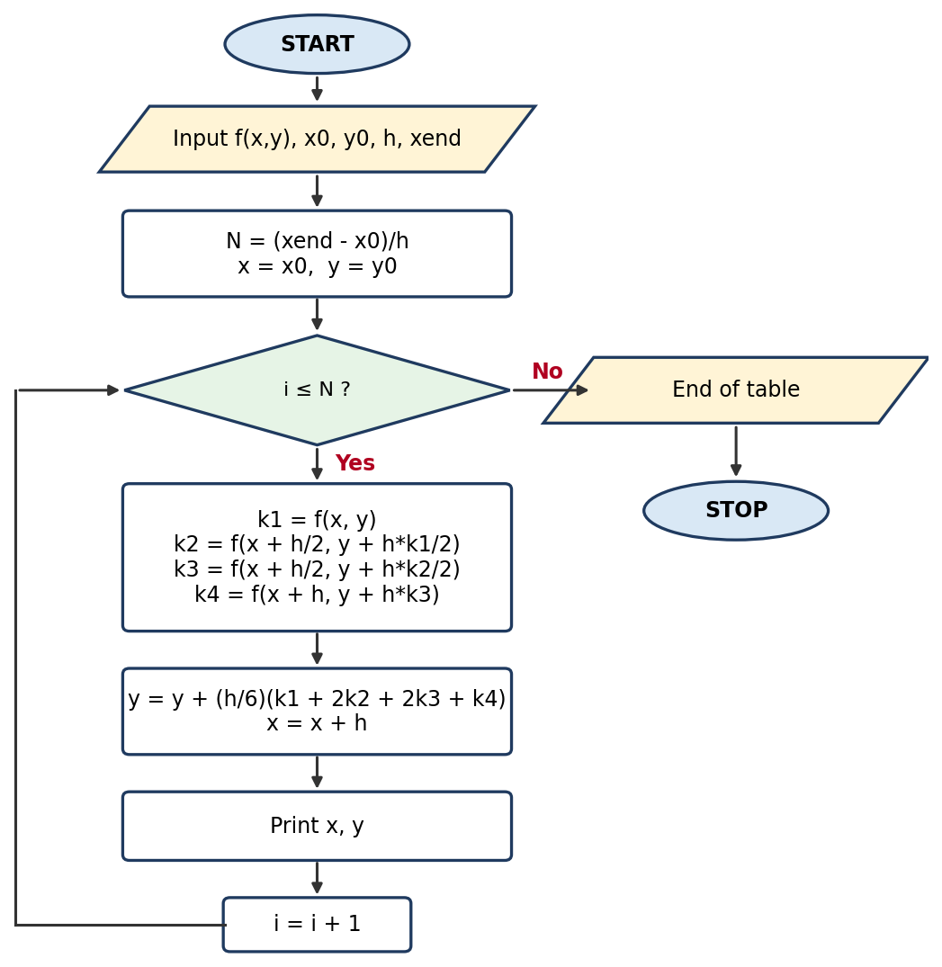

Pseudo code
START
INPUT f(x,y), x0, y0, h, xend
N = (xend - x0) / h
x = x0
y = y0
FOR i = 1 TO N
k1 = f(x, y)
k2 = f(x + h/2, y + h*k1/2)
k3 = f(x + h/2, y + h*k2/2)
k4 = f(x + h, y + h*k3)
y = y + (h/6)*(k1 + 2*k2 + 2*k3 + k4)
x = x + h
PRINT x, y
ENDFOR
STOP

MATLAB code
% 4th-order Runge-Kutta method using a FOR loop
clc; clear;

f = @(x,y) x + y;
x0 = 0; y0 = 1; h = 0.1; xend = 1;
N = round((xend - x0)/h);

x = x0; y = y0;
fprintf('%6s %12s %12s\n', 'x', 'y (RK4)', 'y (exact)');
for i = 1:N
k1 = f(x, y);
k2 = f(x + h/2, y + h*k1/2);
k3 = f(x + h/2, y + h*k2/2);
k4 = f(x + h, y + h*k3);
y = y + (h/6)*(k1 + 2*k2 + 2*k3 + k4);
x = x + h;
fprintf('%6.2f %12.6f %12.6f\n', x, y, 2*exp(x) - x - 1);
end

Output (same for both versions)
x y (RK4) y (exact)
0.10 1.110342 1.110342
0.20 1.242805 1.242806
0.30 1.399717 1.399718
0.40 1.583648 1.583649
0.50 1.797441 1.797443
0.60 2.044236 2.044238
0.70 2.327503 2.327505
0.80 2.651079 2.651082
0.90 3.019203 3.019206
1.00 3.436559 3.436564

B. Solution using a WHILE loop

Flowchart
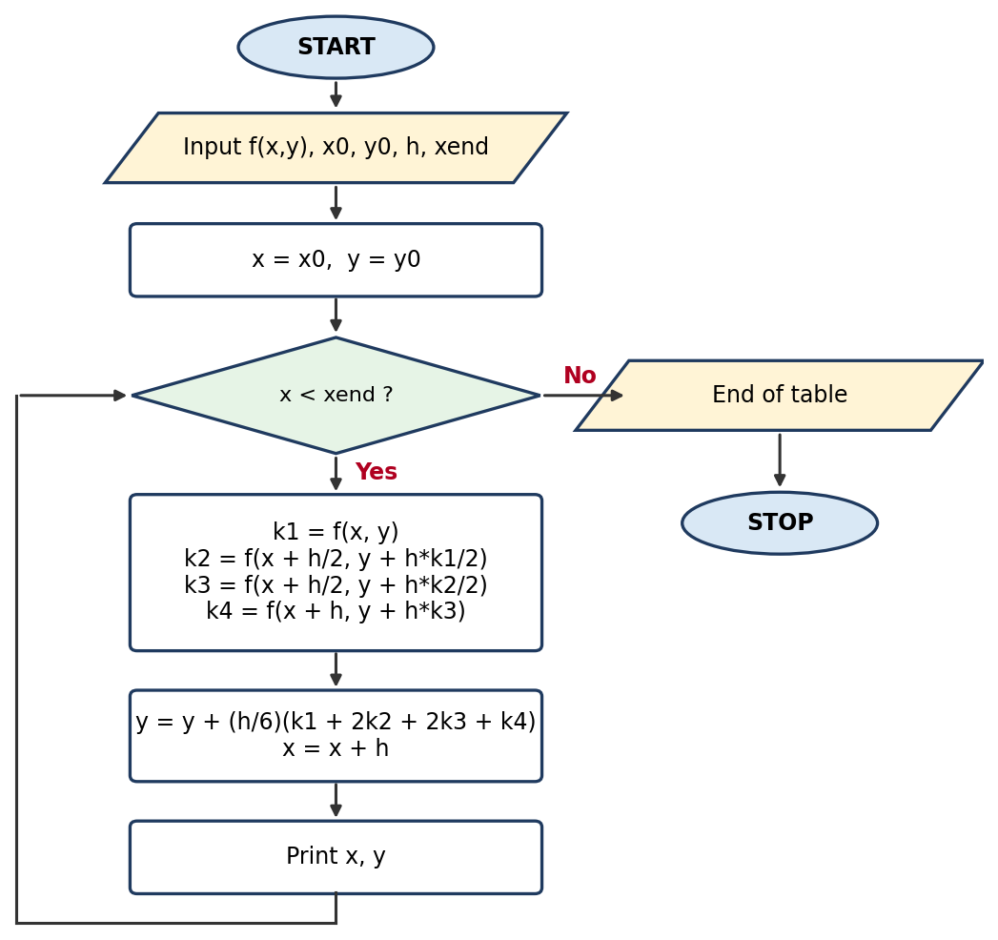

Pseudo code
START
INPUT f(x,y), x0, y0, h, xend
x = x0
y = y0
WHILE x < xend
k1 = f(x, y)
k2 = f(x + h/2, y + h*k1/2)
k3 = f(x + h/2, y + h*k2/2)
k4 = f(x + h, y + h*k3)
y = y + (h/6)*(k1 + 2*k2 + 2*k3 + k4)
x = x + h
PRINT x, y
ENDWHILE
STOP

MATLAB code
% 4th-order Runge-Kutta method using a WHILE loop
clc; clear;

f = @(x,y) x + y;
x0 = 0; y0 = 1; h = 0.1; xend = 1;

x = x0; y = y0;
fprintf('%6s %12s %12s\n', 'x', 'y (RK4)', 'y (exact)');
while x < xend - 1e-10
k1 = f(x, y);
k2 = f(x + h/2, y + h*k1/2);
k3 = f(x + h/2, y + h*k2/2);
k4 = f(x + h, y + h*k3);
y = y + (h/6)*(k1 + 2*k2 + 2*k3 + k4);
x = x + h;
fprintf('%6.2f %12.6f %12.6f\n', x, y, 2*exp(x) - x - 1);
end

Output (same for both versions)
x y (RK4) y (exact)
0.10 1.110342 1.110342
0.20 1.242805 1.242806
0.30 1.399717 1.399718
0.40 1.583648 1.583649
0.50 1.797441 1.797443
0.60 2.044236 2.044238
0.70 2.327503 2.327505
0.80 2.651079 2.651082
0.90 3.019203 3.019206
1.00 3.436559 3.436564

